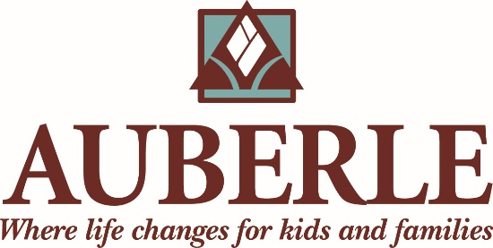
Help Us Change Lives: Auberle Seeks a
Grant Writer/Project Manager
Auberle is seeking a passionate, mission driven, project manager to spearhead request for proposal responses and the individual giving program.
Organization: Auberle is a dynamic, award winning human service agency operating 20+ services from multiple sites with 200+ staff serving 4,000 at risk people annually in Southwestern PA. The success of those we serve has been recognized with many awards including the national Aramark Organizational Leadership Award for “great leadership, strategic governance, a focus on equity, a culture of partnership and innovation, and a commitment to values-based advocacy;” national Agency of the Year by the Alliance for Strong Families and Communities; Wishart Award for Excellence in Nonprofit Management; Smart 50 company by Smart Business magazine; and the Innovation Award from the Pittsburgh Business Times, the only human service agency recognized. Six years in a row the Pittsburgh Post-Gazette has named Auberle a Best Place to Work.
Position Overview: We are seeking a talented professional to fill an immediate need for a Grant Writer/Project Manager. We see this role as essential to the execution of the agency’s strategic plan, raising needed resources and assisting with new programs to advance the agency’s mission. Auberle has launched several new programs each year over the last several years. This position serves as a project manager for program development and plays a key role in helping the agency meet its fundraising goal. A position shared between Development and Strategy, it is housed in the Development Department and supervised primarily by the Chief Strategy Officer. The Development Department is a highly effective team that works to raise individual, corporate, government and foundational support for Auberle’s Mission. The department works collaboratively to meet Auberle’s financial and strategic goals.
Essential Responsibilities:
- Promote the philosophy and Mission of Auberle in the provision of all responsibilities.
- Learn and implement trauma-informed approaches to service delivery and agency culture and functioning by working within the Sanctuary Model.
- Research and Identify prospective individuals, corporations, and foundations as source of new funding. In addition to strong technical writing skills, the ideal candidate will have the ability to project manage, advocate and obtain buy-in from people across the agency.
- Serve as principal grant writer including, but not limited to, conducting preliminary research on prospective corporate, foundation and federal funding opportunities; timely submitting proposals and reports to agency leaders for review, incorporating agency leaders’ edits and feedback, and maintaining reporting deadline calendar.
- Work closely and passionately with agency leaders to successfully respond to Federal, State and County Requests for Proposals.
- Employ strong writing acumen with attention to detail; and proactively pursue budget data and program information for proposals’ timely submission.
- Proactively learn about Auberle’s programs and incorporate current statistics and outcomes into proposals and communications.
- Write, contribute or edit articles for annual report and other agency communications such as Good Kids newsletter, Employee of the Month interviews and other marketing materials.
- Support overall operations for the department by compiling monthly fundraising reports, as well as other reports as needed.
- Act as relationship manager for a group of donors, as agreed upon with the Director of Development, to drive their cultivation and engagement with Auberle.
- Market the agency through the use of outcome data to regularly communicate with donors, referral agencies, key decision makers, clients and volunteers.
- Demonstrate an understanding of and respect for the cultural diversity of consumers, volunteers, staff and other stakeholders.
- Lead and follow as directed.
- Perform all other duties as assigned by the CEO, COO, CSO and DOD.

Required Skills and Abilities:
- Possess and communicate a passion for Auberle’s Mission.
- Strong writing skills.
- Strong familiarity with social media platforms.
- Strong relationship building skills.
- Desire to work in a fast-paced, performance-based team environment.
- Strong donor cultivation and stewardship skills.
- Must be proficient in Microsoft Word, Excel, PowerPoint and database software (DonorPro, Qualifacts experience is a plus).
- Ability to manage multiple projects, meet deadlines, work independently, and receive feedback and direction.
- Ability to work effectively and flexibly with individuals at all levels.
- Ability to exercise discretion and maintain confidentiality.
- Ability to demonstrate effective leadership, organizational, and time management skills.
Qualifications and Requirements:
Bachelor’s Degree required; Master’s Degree in nonprofit management or a related field preferred. Must be 21 years of age or older and required to apply for Act 33/34 clearances (criminal and child abuse) as well as FBI clearance. Pre-employment drug screening and random employment drug testing required.
Auberle offers a comprehensive benefits package and excellent training opportunities. If you’re motivated by an opportunity to use your talent and expertise to truly make a difference, be sure to apply on the Auberle website, www.auberle.org. EOE

